01 Project Information
Sri Gowtham CBSE School, Malkipuram
MEDISETU AI
AI-Powered Robo Doctor for Unreached Communities
02 Theme
Public Health and Hospitals
03 Swarna Andhra Sutra(s)
1. Zero Poverty-The project supports access to affordable and basic healthcare by bringing preliminary health screening closer to communities that may have difficulty reaching healthcare facilities.
2. Deep Tech in All Walks of Life
Using AI, robotics, sensors, Python programming, and cloud technology to provide basic health-screening support to people in underserved and unreached communities.
The project aims to bring basic health screening and health guidance closer to people in rural and unreached communities where access to doctors and healthcare facilities may be limited.
04 What is the Problem?
In rural and unreached communities, people may have to travel long distances to access healthcare facilities. In some situations, even obtaining basic health measurements such as blood pressure, blood glucose, temperature, and oxygen level can require visiting a healthcare center.
People may also find it difficult to understand their health readings or know whether they should continue monitoring their condition, consult a health worker, or seek medical attention.
This can result in delays in identifying situations that require professional medical attention.
The project addresses the specific problem of limited access to basic health screening and understandable health information in remote communities.
05 What is Your Proposed Solution?
We propose an AI-Powered Robo Doctor with a robotic hand interface that can assist with basic health screening in unreached communities. The Robo Doctor has a robotic hand-shaped unit. The user is instructed to place/keep their hand inside the designated robotic-hand area. The system then guides the user through the screening process. The robotic unit is connected to health-monitoring devices and sensors that collect basic health information such as:
- Blood glucose
- Blood pressure
- Oxygen saturation (SpO₂)
- Body temperature
- Pulse rate
The measurements are sent to a Raspberry Pi, which acts as the main processing unit. A Python-based AI program analyzes the collected information using a trained classification algorithm. The AI identifies whether the measurements require routine monitoring, further attention, or professional medical assessment based on the programmed/reference criteria.
The result is displayed on a monitor in a simple format.
The Robo Doctor can also:
- Display the readings and screening result
- Speak the result and instructions through voice output
- Print a simple screening report
- Store records securely in cloud storage for authorized follow-up
A local RMP/health worker can use the displayed or printed information as an additional screening aid and help the person decide whether they should be referred to a qualified doctor or healthcare facility.
The system is therefore designed as an AI-assisted screening and first-level guidance system, rather than replacing a qualified doctor.
06 Additional Information
Working Model
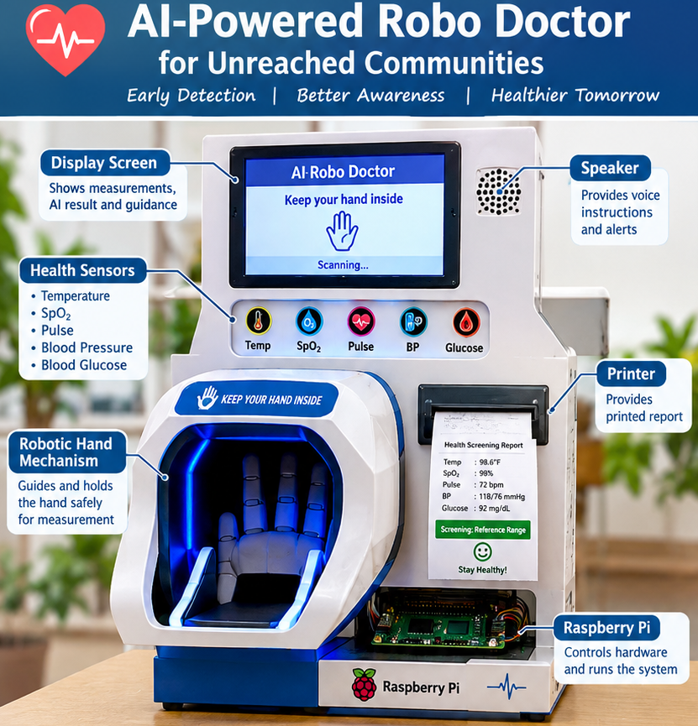
07 Team Members
Charan Kandula
Teja Belamkonda
Mohan Dodda
Satwik Kommula

